ENVIRONMENT MANAGEMENT PLAN
Of
{projectName}

Village | {villageName}
Tehsil | {projectTehsil}
District | {projectDistrict}
Area | {projectArea}
Khasra No. | {projectKhasraNo}
Production Capacity | {projectProductionCapacity}

Applicant
{applicantName}
{applicantAddress}
{applicantEmail}
{applicantMobile}

Prepared By


Aseries Envirotek India Private Limited
(QCI/NABET APPROVED)
NABET/EIA/2225/RA 0275
Address- 973 (Part), SainikVihar Phase-2,
Near CRPF Camp, Gate No. 2, Sarojini Nagar
Lucknow (U.P.)-226008
Mail ID- aseries.envirotek@gmail.com
Phone No- 0522-711873
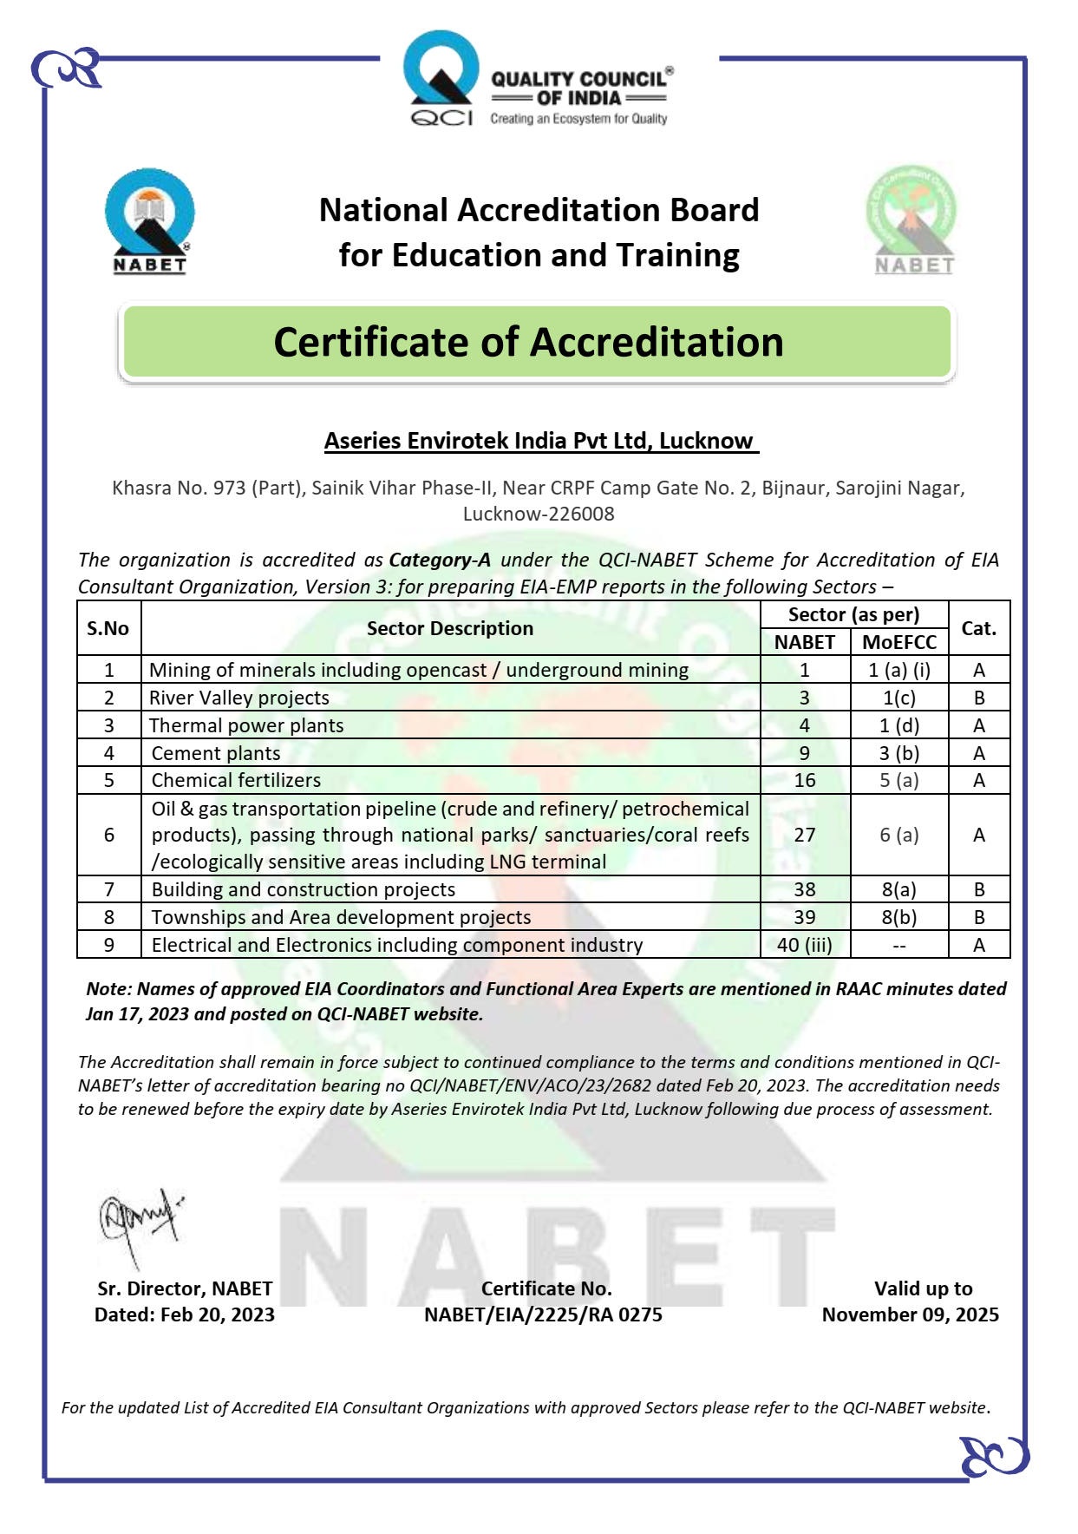

Table of Content
S.No. | Particulars | Page No.
 | Introduction | 04
 | Mitigation measures | 04-06
 | Land environment | 07
 | Solid waste management | 08-09
 | Biological Environment | 09-10
 | Occupational Health And Safety Measures | 10-11
 | Environmental Monitoring Program | 11-12
 | Socio-Economic Environment | 12-13
 | Conceptual Mine Closure Plan | 14
Table Nos.
1. | Computation Of Annual Runoff in Minable Area | 05
2. | Details of Garland Drain & Settling Tank | 05
3. | Land Use | 07
4. | OB/ waste Generation and management | 08
5. | Proposed Plantation | 09-10
6. | Monitoring Schedule For Environmental Parameters | 12
7. | EMP Cost | 12-13

- INTRODUCTION
- MITIGATION MEASURES
- LAND ENVIRONMENT
- SOLID WASTE MANAGEMENT
- BIOLOGICAL ENVIRONMENT
- OCCUPATIONAL HEALTH AND SAFETY MEASURES
- ENVIROMENTAL MONITORING PROGRAM
- SOCIO-ECONOMIC ENVIRONMENT
- CONCEPTUAL MINE CLOSURE PLAN

